UppSite: Read Me

**Wordpress Plugin Installation Guide**

# Getting Started

In order to turn your forum into mobile-apps, please follow these simple steps:

## Register Your Website with UppSite

Note: If you have already registered your website on UppSite.com, you may go directly to Step 5: Install the UppSite plugin on your vBulletin forum.

1. First, go to <http://www.uppsite.com>

2. Enter your website and click on the "Start" button:



3. Create a new user account by entering your email address and a username of your choice.  
Your password will be emailed to the email you input, so it is important to enter a correct address. When done, press the "Register" button.

4. On the next page, download the UppSite plugin file onto your computer.  
You may save the file on your desktop for easy access later on, when you are required to install it. The file name should be: "999_uppsite.zip".  
If you already have our plugin installed, you may skip saving this file to your computer.  
When done, do not close this page.

5. Install the UppSite plugin on your Wordpress blog

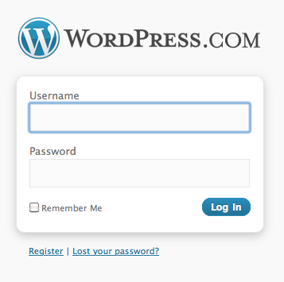5.1. In a new browser window, login to your blog.  
The login page should be http://www.EXAMPLE-WEBSITE.com/wp-login.php

5.2. If you were not redirected automatically to the blog Dashboard, select ‘Dashboard’ from the top menu.

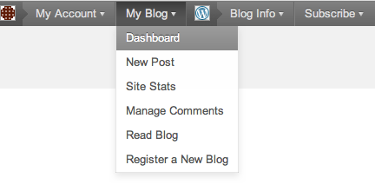

5.3. Select the ‘Plugins’ option from the menu on the left.

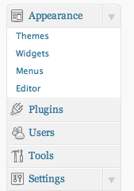

5.4. Next, select the ‘Add New’ option.

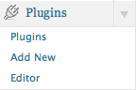

5.5. Then, select the ‘Upload’ option from the top menu.



5.6. If a form should appear, please fill it in your relevant FTP account details.

If you do not have your FTP account details, please contact your hosting provider and request them.

5.7. Choose the plugin file from your computer and press ‘Install Now’.

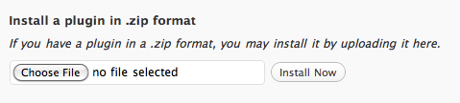

5.8. If a special message appears on the top part of your blog Dashboard requesting you to configure the plugin, please follow the instructions attached to this message.

6. Back on UppSite's website registration process, at the bottom of the plugin download page, now click on the "I'VE SUCCESSFULLY INSTALLED THE PLUGIN, LET'S CONTINUE" button.

7. On the new page, please fill out the final registration form. The information on this form will produce your mobile apps.  
Upon completing the form, click "Finish" and then, click on “Create My Apps” when it appears on the pop-up window.

8. That’s it!  
Your apps will be created shortly. You will be notified by email when your apps are uploaded to the Application Stores selected on step 7 of this guide.